Knowledge Watchkeeping
Closed Book
Participant Name |  | Signature
RTO Name / Code | Seafood & Maritime Training 7074 | Date of Assessment
Course Name | Coxswain Deck
UoC partially mapped to this assessment | MARI003 Comply with regulations to ensure safe operation of a vessel up to 12 metres
Participant Instructions on Assessment | This assessment is to be completed by participants and will be used as evidence of the participant achieving competency.  - Write your name, date and signature at the top of this Assessment  - This assessment is to be completed within the allocated time of 45 minutes and is a closed book assessment.  - A satisfactory answer to each question is required as acceptable  - Write your answers on this Assessment in the spaces provided. If you need more space to write your answer, use a blank sheet of paper obtainable from your trainer  Resources Required:  - No specific resources are required for this assessment
Assessment  Outcomes: | S – Satisfactory  NS – Not yet Satisfactory
Watchkeeping |  |  |  | S / NS
Within the scheduled duration of the training and assessment if the participant is found not satisfactory, please fill in a Participant Development Report.
In finding the participant satisfactory they have met the requirements of this assessment:
Trainer/Assessor Name: ____________________ Signature: _____________________

Date: ______________________

Assessor Notes:  While undertaking the scheduled training | E.g. Q1 – needs a more detailed answer.  ________________________________________________________________________________________________________________________________________________________________________________________________________________________________________________________________________________________________________________________________________________________________________________________________________________________________________________________________________________________________________________________________________________________________________________________________________________________________________________________________________________________________________________________________________________________________________________________________________________________________________________________________________________________________________________________________________________________________________________________________

Watchkeeping | S | NS
- When two (2) vessels are approaching one another, a risk of collision can exist when.

- The distance of the approaching vessel is closing.
- The compass bearing of the approaching vessel is steady.
- An appreciable bearing change is evident when approaching a large, close vessel.
- All of the above

I003-PC1.1, 1.3, 3.2 P1, P4, P5, K8, K11
- Two (2) power-driven vessels are crossing and there is a risk of collision.
A

- Who is the stand-on vessel,
_________________________________________________
B

- What is the action of the give-way vessel.
_________________________________________________

- Draw the actions for each vessel to avoid collision.

I003-PC1.1, 1.3, 3.2, 3.3, P1,P5, K8,11
- Vessel ‘A’ is overtaking Vessel ‘B’.
Vessel ‘A’ can overtake Vessel “B”.

- Portside only,
- Starboard side only.
- Either side (Pending safe navigation)
What action shall Vessel ‘B’ take whilst being overtaken.
A
_________________________________________________

Draw which way Vessel ‘A’ can overtake Vessel ‘B’.

I003-PC1.1, 1.3, P5, K8, K11
Watchkeeping | S | NS
- In a distress situation, list three (3) ways you would raise the attention of another vessel within sight.
1.________________________________________________________________________
2.________________________________________________________________________ 3.________________________________________________________________________
I003-PC1.1, 1.3, 2.1, P2, P5, K11, K13
- On which side of this Cardinal Mark is safe water.
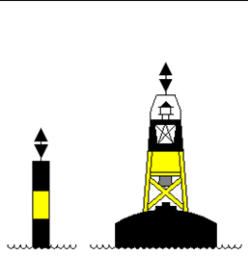
North East South West
(circle your answer)

I003-PC1.1, 1.3, P5, K7,
- Describe the light colour and flashing characteristic of an Isolated Danger Mark

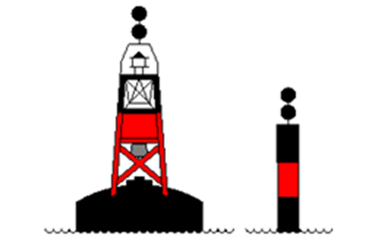
Colour _______________________

How many flashes? _____________

I003-PC1.1, 1.3, P5, K7
- When leaving Harbour, which side of your vessel should you keep this mark.

Port 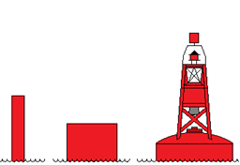 Starboard
(Circle your answer)
I003-PC1.1, 1.3, P5, K7
Watchkeeping | S | NS
- Using the chart provided, draw a safe route from Position A to Position B.
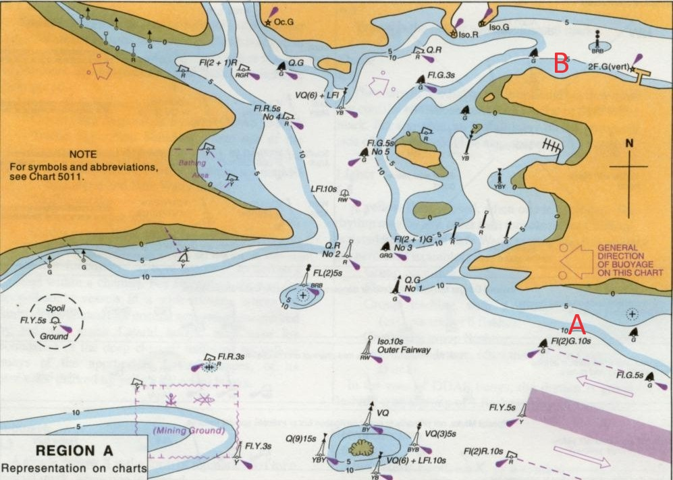

9. When determining a safe speed for your vessel, list five (5) factors the COLREGS require you to consider.  1._____________________________________________________________________  2._____________________________________________________________________  3._____________________________________________________________________  4._____________________________________________________________________  5._____________________________________________________________________  I003-PC1.1, 1.3, 3.4, P5, K8, K11 |  | `

